Introduction
We are syncronizing the MBFIA newsletters to the start of each season. This is the Summer 2026 edition reflecting upon the ‘reopening’ of the parks. They never really close, but the recent Memorial Day long weekend is the tratitional start to the season. This is also leading us to July 4th as America celebrates the Semiquincentennial of the signing of our Declaration of Independence. In the Autumn newsletter we will look forward to Heritage day. And to finish the year and look forward to the next, the Winter newsletter will start the Centennial celebration of the McArthur-Burney Falls Memorial State Park.

Photo

Upcoming Dates in 2026
- Friday June 19 – Juneteenth
- Sunday, June 21 – Beginning of Summer
- Friday, July 3 – Independence Day Bank Holiday

- Saturday, July 4 – 250th Anniversary Independence Day
- Monday, September 7 – Labor Day
- Wednesday, September 9 – California Admission Day
- Saturday, September 12 – MBFIA Volunteer Appreciation Day & Lunch
- Tuesday, September 22 – Beginning of Autumn
- Sunday, October 11 – McArthur-Burney Falls Heritage Day Celebration
- Monday, October 12 – Columbus Day
- October 31 – Most seasonal facilities close
- Wednesday, November 11 – Veterans Day
- Thursday, November 26 – Thanksgiving
- Monday, December 21 – Beginning of Winter
- Friday, December 25 – Christmas
- Friday, January 1, 2027 – New Years Day

Table of Contents
Introduction 1
Photo 1
Upcoming Dates in 2026 1
Memorial Tables 3
Board Members 3
About MBFIA 3
Firewood at the Falls 3
Friends of the Falls 4
Donations 4
Chief Ranger’s Message 4
President’s Message 4
Meet 5
Webmaster Bob Boyce 5
Falls Visitor Center 5
Visitor Center Store 5
About the Three State Parks 6
Repeat every time? Yes! 6
McArthur-Burney Falls Memorial State Park 6
Castle Crags State Park 7
Ahjumawi Lava Springs State Park 7
Featured Artist this Quarter: 8
Burney Falls General Store 8
Job Openings 8
Any new? Keep these open? 8
MBFIA Bookkeeper 8
Camp Hosts 9
Visitor Services Senior Park Aide 9
Contact Infomation 9
In the Area 9
On the Internet 10
MBFIA (McArthur-Burney Falls Interpretive Association) 10
Burney Falls General Store 11
MacArthur-Burney Memorial State Park 11
Castle Crags State Park 11
Ahjumawi Lava Springs State Park 12

Memorial Tables
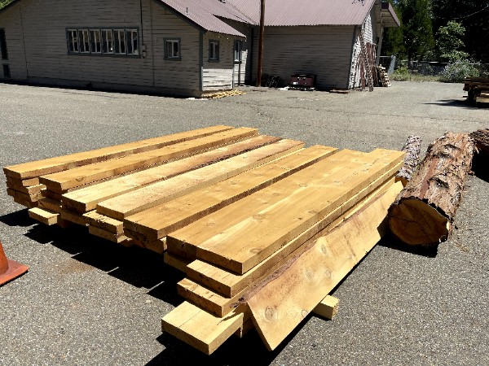
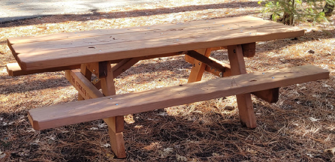
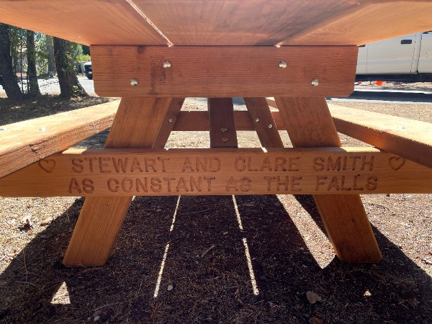
We are thrilled to offer you a limited opportunity to purchase an engraved memorial table to be placed in the Park for years to come! Here's your opportunity to contribute a tax-deductible gift to the Park and to create an everlasting memory of a special time at the park or in honor of a family member or friend, while contributing to the Friends of the Falls at the same time! Contact Bill McSweeney at: calpacker@comcast.net or 415-726-3241 for information and an application!The MBFIA builds memorial tables and places them throughout the parks. They can be purchased for $2800. Each end can have memorial information etched into the bench.
Photo with yellow paint in the routing

Board Members
- President Jim Sacson
- Vice President: Mark Downie
- Secretary: Ann Sacson
- Treasurer Emiritus: Jaci White
- Webmaster: Bob Boyce
- Bill McSweeney
- Media Rep: Craig Harrington
- Newsletter Editor: Tony Otto
- Volunteer: Susan Lamke
- Alice Hoveman
- Jill Overbaugh
- Tom Stockton
- New person

About MBFIA
The McArthur Burney Falls Interpretive Association (MBFIA) is an all-volunteer non-profit education organization that provides assistance and funding for activities which enhance the quality of visits to McArthur Burney Falls Memorial State Park, Castle Crags State Park and Ahjumawi Lava Springs State Park. The association was founded in 1984 to promote greater appreciation of the cultural and natural history of the region.

Firewood at the Falls
The MFBIA has firewood in 0.8 cubic foot bags available just past the entrance kiosk and at the upper and lower campground areas when open. The cost is $10/one bag, $18/two bags, and $25/three bags.

Friends of the Falls
Friends of Burney Falls provides education and interpretation and our programs highlight the Park's natural and cultural elements. Burney Falls offers hiking trails, flora and fauna, birds, squirrels and the like, camping, cabins and Lake Britton. Funds donated support Interpretive and educational activities, including guided hikes, Junior Ranger programs, campfire and craft activities, sing-alongs and group games. At Burney Falls, our Visitor Center includes a Gift Shop, as well as information about the geology, flora and fauna, cultural history and recreational opportunities in the park and the surrounding area. Our annual Heritage Day celebration in October offers weaving, cross-cut sawing, branding, candle-making, pine-doll making, apple cider pressing and Dutch Oven cooking. The Park has instituted a birding program, that includes guided bird identification walks, loaner binoculars plus a library of information. In addition, we have supported new native plants around the Visitor Center, with information about the plantings available for visitors.
We're also in the process of renewing our availability for sale and placement of memorial benches and picnic tables at the Park. Contact us for more details.

Donations
We encourage every visitor to make a donation in any amount to support activities in the Park. Checks may be made payable to MBFIA, Box 777, Burney CA 96013. Donation envelopes are available in the kiosk at the entrance or in the Visitor Center. We will list donors in next year’s Visitor Guide.

Chief Ranger’s Message
Blair Headshot Photo
Blair’s message about the new reservation system implemented starting May 15. Warnings for upcoming holidays on July 4th and Labor Day.
.
.
.
.
.

President’s Message
Summer Message from Jim. Crop photo to headshot.
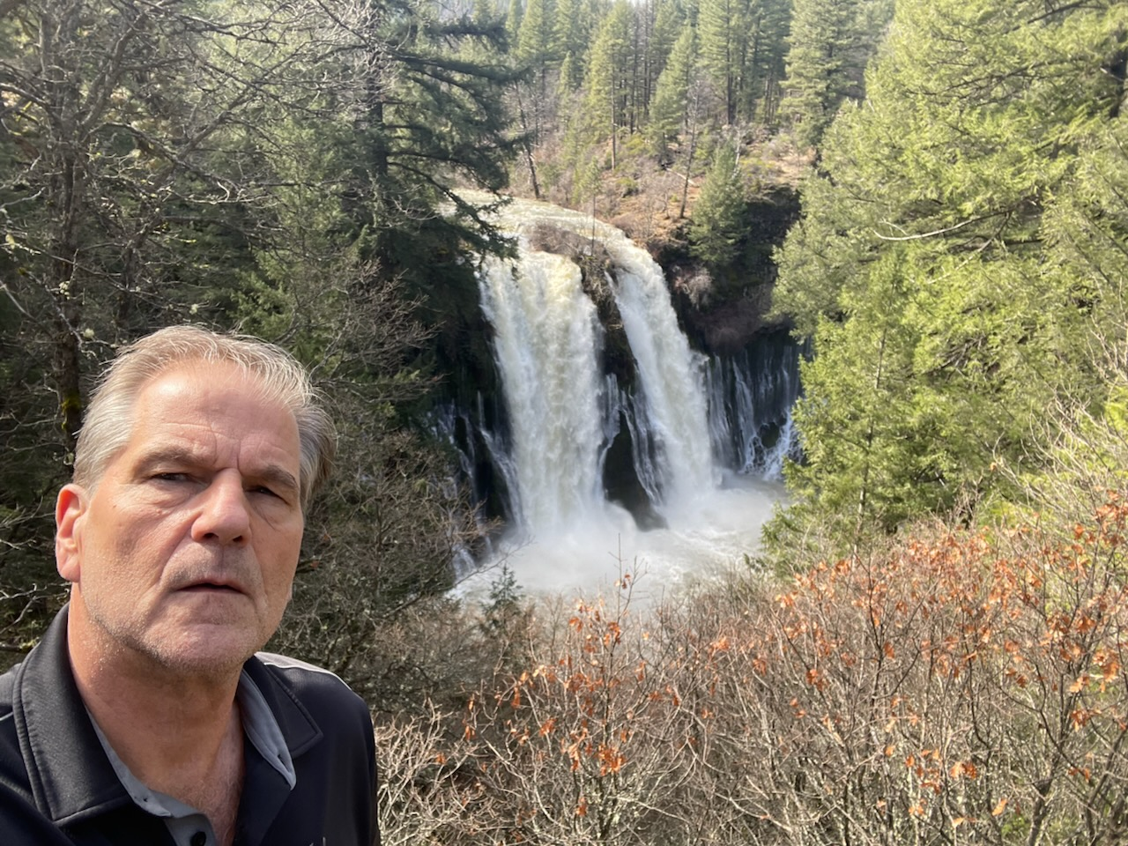

Meet

Webmaster Bob Boyce
Photo and couple paragraphs
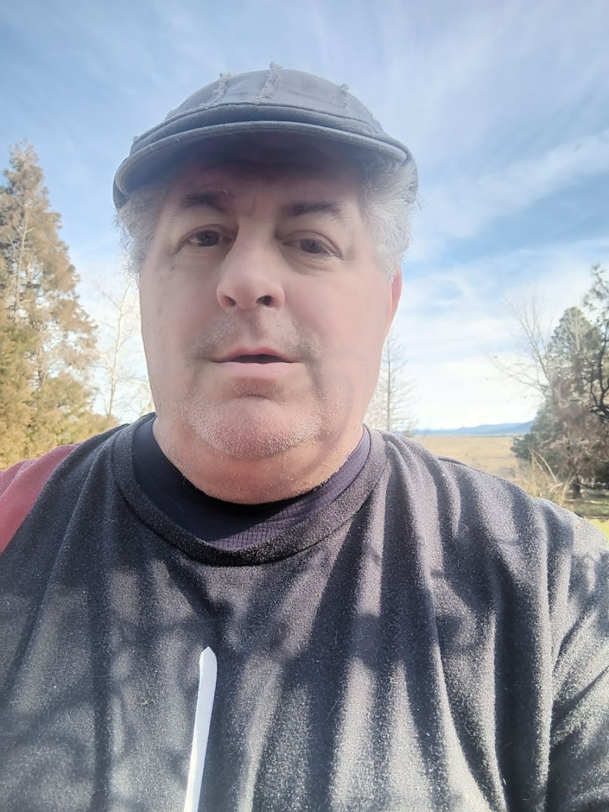
,
,
,
,
,
,
,
,
,

Falls Visitor Center
The MBFIA operates the visitors center at the main parking lot above the falls. There you will find informative panels about the , the park, and the local flora & fauna. Several art exhibits are displayed in the center, including: Ed. Note: See this quarter’s featured artist below.

Visitor Center Store
The 2026 T-Shirts are now available at the Visitor Center Store.
Update List?
At the center, you will find these items for sale:
- Water Bottles and Mugs
- Stuffed Birds that frequent the park
- Patches and Badges
- Magnets and Pins
- Camping supplies
- Walking Sticks
- T Shirts with color print of McArthur Burney Falls
- Hats
- Sweatshirts
- Guides to Wildlife
- Gifts from Local Artists
  - Pottery
  - Pine Cone jewelry and tools
  - Watercolor originals and prints of the park

About the Three State Parks

Repeat every time? Yes!

McArthur-Burney Falls Memorial State Park
The park is within the Cascade Range and Modoc Plateau natural region, with forest and five miles of streamside and lake shoreline, including a portion of Lake Britton.
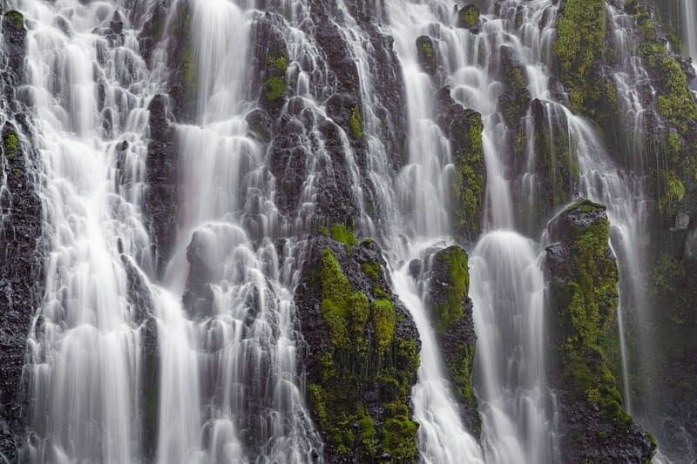Courtesy CA State Parks
The park's centerpiece is the 129-foot Burney Falls, which is not the highest or largest waterfall in the state, but possibly the most beautiful. Additional water comes from springs, joining to create a mist-filled basin. Burney Creek originates from the park's underground springs and flows to Lake Britton, getting larger along the way to the majestic falls.
The park's landscape was created by volcanic activity as well as erosion from weather and streams. This volcanic region is surrounded by mountain peaks and is covered by black volcanic rock, or basalt. Created over a million years ago, the layered, porous basalt retains rainwater and snow melt, which forms a large underground reservoir. Within the park, the water emerges as springs at and above Burney Falls, where it flows at 100 million gallons each day. Burney Falls was named after pioneer settler Samuel Burney who lived in the area in the 1850s. The McArthurs were pioneer settlers who arrived in the late 1800s. Descendants were responsible for saving the waterfall and nearby land from development. They bought the property and gave it to the state as a gift in the 1920s. This year, we experienced heavy snow in mid-February so the falls were flowing exeptionally heavy.
Cellular service in the park continues to improve, so you should be able to find a signal as you travel the roads.

Visitor Information for the Falls:
McArthur Burney Falls Memorial State Park entrance kiosk is open now, but closed in the off-season. Please bring exact change or credit/debit cards to pay by APM (Automatic Payment Machine) which is located just pass the entrance kiosk in front of the visitor center.
- Park Day-Use Fee - $10 Per Vehicle
- Overnight Camping - $35 Per Night (Includes One Vehicle).
- Additional Overnight Camping Vehicles - $10 Per night.

Warnings for Falls Vistors:
McArthur Burney Falls State Park experiences extremely high visitation beginning in April and continuing through October. Most weekends all summer the park will fill to capacity and entrance into the park is subject to closure due to limited parking availability. Visitors should expect traffic delays on State Highway 89 for up to an hour prior to entering the park due to the increased visitation experienced at this park. It is illegal to park along Highway 89 outside of the park for a mile either direction. If you park along Highway 89 your vehicle will be subject to citation and tow. The speed limit is 55 mph along Highway 89 and utilized by a large volume of semitrucks, it is not recommended to walk along the highway. If you arrive to find the entrance closed due to full capacity, please return at a later time - typically after 4:00 p.m.
The park cannot admit entrance to vehicles over 32 feet for day-use or camping. Additionally, only a limited number of oversized vehicles (less than 32 feet in length) will be admitted into park. Oversized vehicles will only be allowed to park in the Lake Britton parking lot (approximately 1.5 miles walk to the falls) on Fridays, Saturdays, and Sundays.
Due to limited parking capacity, McArthur-Burney Falls Memorial State Park cannot accommodate entry, drop-offs or parking of tour busses until further notice.

Castle Crags State Park
Majestic Castle Crags have inspired enduring myths and legends. More than 170 million years old, these 6000-feet tall granite spires in the Castle Crags Wilderness border the northwestern edge of Castle Crags State Park.

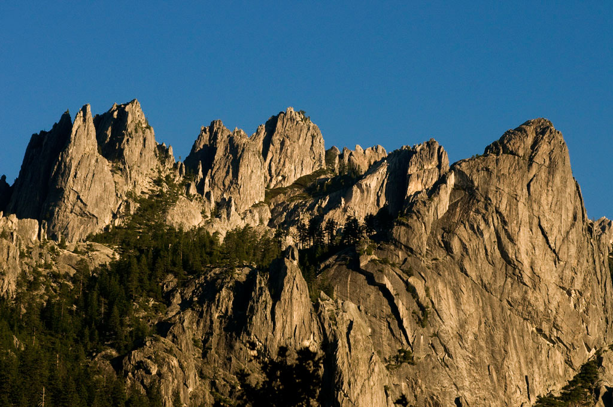Courtesy of California State Parks, 2026.
Castle Crags State Park offers a variety of camping, picnicking, hiking, and fishing opportunities.
The park has 76 developed campsites that are each equipped with a picnic table, food locker, and a fire ring. Flush toilets, showers, and drinking water are available near each campsite. Picnic sites are located along the Sacramento River and at the awe-inspiring Vista Point.McArthur Burney Falls State Park experiences extremely high visitation beginning in April and continuing through October. Most weekends all summer the park will fill to capacity and entrance into the park is subject to closure due to limited parking availability. Visitors should expect traffic With 28 miles of hiking trails, everyone can enjoy a mild stroll or an invigorating adventure. From the Vista Point parking area, a quarter mile accessible trail leads visitors to Vista Point where there are dramatic views of Castle Crags, Mount Shasta, and nearby Grays Rocks. Gentle and shaded, the mile long Root Creek Trail guides hikers along an accessible path to a year round flowing creek.
The most popular and challenging route is the Crags Trail which leads adventures to the base of Castle Dome where the views are simply breathtaking. The Pacific Crest Trail winds through the Park as well. Castle Crags State Park is often a respite for the weary hikers of this 2,650 mile trek from Mexico to Canada.
The Sacramento River flows through the park and has several access points that allow for fishing and hiking. Facilities at Riverside include camping and picnicking sites as well the famed pedestrian suspension bridge that crosses the Sacramento River.

Ahjumawi Lava Springs State Park
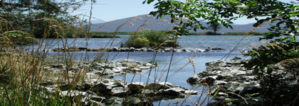
"Where the waters come together...." is a translation of the California Indian word Ahjumawi, which is also the self describing word used by the band of Pit River of Indians who still inhabit the area.
Ahjumawi is a place of exceptional, even primeval, beauty. Brilliant aqua bays and tree studded islets only a few yards long dot the shoreline of Ja-She Creek, Crystal Springs, and Horr Pond. Over two thirds of the area is covered by recent (three to five thousand years) lava flows including vast areas of jagged black basalt.
The park's backcountry is charactarized as wilderness with extremely rugged lava rock. Visitors should prepare adequately for their visit. While there are over twenty miles of park trails by which to explore this beautiful geographical wonder, please be advised that travel off the trails requires proper preparation and equipment. Be sure someone knows where you are going and when you expect to return.

Featured Artist this Quarter:
Pine Cone Cob Brothers
,
,
,
,
,
.
.
.
.
.
.
.
.
.
.
.
.
.
.
.

Burney Falls General Store
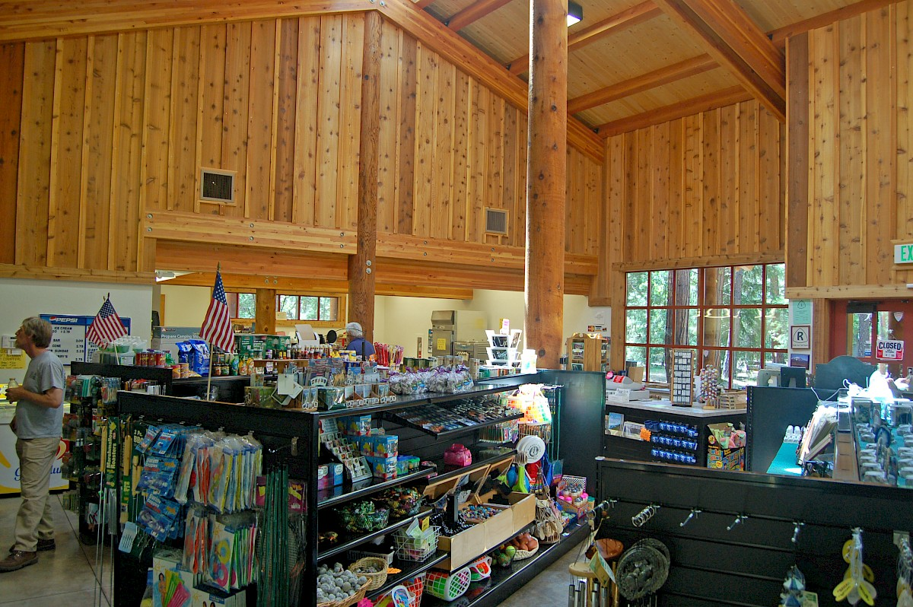
Conveniently located within Burney Falls State
New photo?
Park, the Burney Falls General Store is your go-to stop for essential supplies and quick refreshments. You’ll find a variety of cold drinks, tasty treats, and basic camping necessities—all surrounded by the beauty of the park’s towering pines and tranquil atmosphere. Friendly staff and a rustic setting make it a welcoming stop for campers and day visitors alike.
Ed. Note: See the link to the General Store website in the ‘On the Internet’ section at the end of this newsletter.

Job Openings

Any new? Keep these open?

MBFIA Bookkeeper
The Association needs a bookkeeper/treasurer to join the Board on a volunteer basis. This is a great way to give back to the community, working with a group of like-minded people who get a kick out of helping to improve three local State parks, including MacArthur-Burney Falls Memorial State Park. Great for a retired person who wants to keep active up to 10 hours a week. Knowledge of Quick Books helpful. Contact Board President Jim Sacson at (530) 513-7102.

Camp Hosts

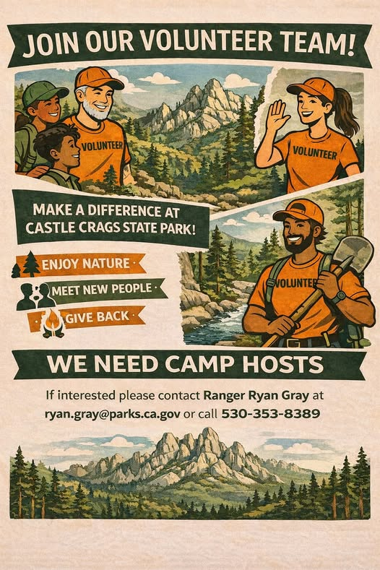
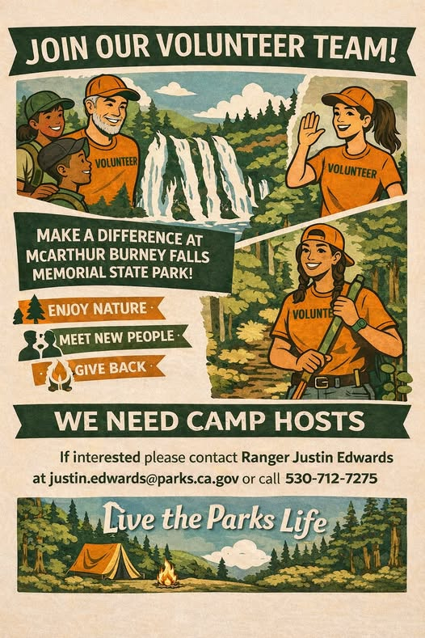
Visitor Services Senior Park Aide
The Visitor Services Senior Park Aide (Seasonal) is expected to work weekends, holidays, and evenings if necessary and assigned days off may vary from month to month. The Visitor Services Senior Park Aide (Seasonal) will perform duties dressed in full State Park uniform.
Primary duties include but are not limited to: Park Aide Lead and administrative duties such as maintaining accountability worksheets, attendance records, and Park Aide schedule, training new Park Aide staff, providing direction and assistance to Park Aide staff, and receptionist duties for the office. The Senior Park Aide (Seasonal) will also
operate the entrance station, greet visitors, and provide information about park conditions, closures, trails, and rules and regulations. In addition, the Senior Park Aide (Seasonal) should be proficient in basic use of a computer and able to check work e-mail account.

Contact Infomation
- MBFIA (McArthur-Burney Falls Interactive Association), PO Box 777, Burney 96013, friends@burneyfallspark.org
  - Burney Falls Visitor’s Center: (530)‌ 335-3171
  - Board President Jim Sacson: jimsacson@gmail.com, (530) 513-7102
  - Webmaster Bob Boyce: webmaster@burneyfallspark.org
  - Tablemaster Bill McSweeney: calpacker@comcast.net
  - Newsletter Editor Tony Otto: tony.otto.frm@gmail.com, (530) 610-2133
- McArthur-Burney Falls Memorial State Park, 24898 CA Hwy 89, Burney, CA 96013,(530) 335-2777
  - Falls Ranger Justin Edwards, justin.edwards@parks.ca.gov, (530) 712-7275
- Castle Crags State Park, 20022 Castle Creek Road, Castella, CA 96017, https://castlecragspark.org/
  - Crags Ranger: Ryan Gray, ryan.gray@parks.ca.gov, (530) 353-8389

In the Area
Please support the advertizers from the annual Visitors Guide that make the free guide available to each carload of visitors to the parks.
- Grocery Outlet
- .
- .
- .
- .
- .
- .
- .
- .
- .
- .
- .
- .
- .
- .
- .
- .
- .
- .
- .
- .
- .
When you visit the parks, there are plenty of aminites to make your time pleasurable.
- .
- .
- .
- .
- .
- .
- .
- .
- .
- .
- .

On the Internet

MBFIA (McArthur-Burney Falls Interpretive Association)
https://burneyfallspark.org/
https://www.parks.ca.gov/?page_id=28535
https://www.facebook.com/BurneyFallsPark/
https://burneyfallspark
.networkforgood.com/
https://projects.propublica.org/nonprofits/organizations/680041373

Burney Falls General Store
https://burneyfallshospitality.com/

MacArthur-Burney Memorial State Park
https://www.parks.ca.gov/?
page_id=455

https://en.wikipedia.org/wiki/McArthur
%E2%80%93Burney_Falls_Memorial
_State_Park
https://www.facebook.com/mbfmsp/
https://www.tripadvisor.com/
ShowUserReviews-g32125-d102684-
r240734010-
McArthur_Burney_Falls_Memorial_St
ate_Park-Burney_California.html
https://www.reddit.com/r/
norcalhiking/comments/1l2y6v9/
mcarthur_burney_falls/

Castle Crags State Park
https://www.parks.ca.gov/?
page_id=454
https://castlecragspark.org/
https://en.wikipedia.org/wiki/
Castle_Crags
https://wilderness.net/visit-
wilderness/?ID=103

Ahjumawi Lava Springs State Park
https://www.parks.ca.gov/?
page_id=464
https://www.visitcalifornia.com/
experience/ahjumawi-lava-springs-
state-park/
https://www.shastacascade.com/
account/ahjumawi-lava-springs-state-
park
https://en.wikipedia.org/wiki/
Ahjumawi_Lava_Springs_State_Park

